Step 7

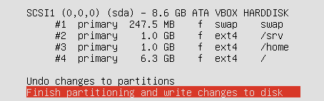

Part 2

Assign IP to server 2

Sudo vi /etc/network/interfaces



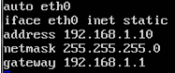

Step3

Pinging machines from srv1

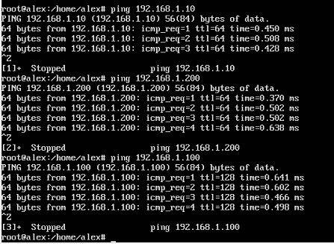

Pining machiens from srv2

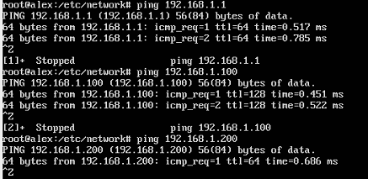

Pinging machines from Ubuntu client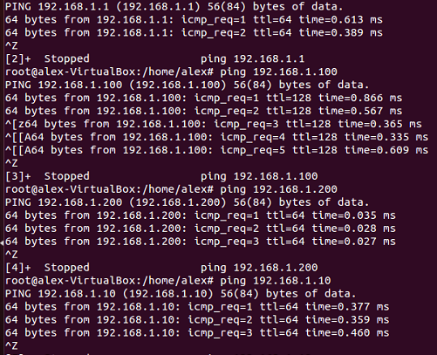

Pining from xp machine

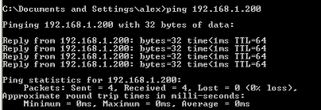

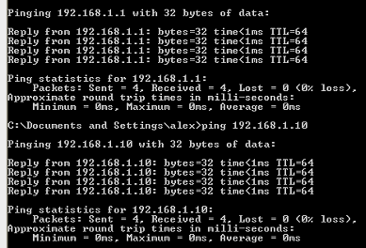

Part 3

Sudo apt-cdrom add

Sudo apt-get install samba

Sudo apt-get install openssh-sever

Vi /etc/samba/smb.conf

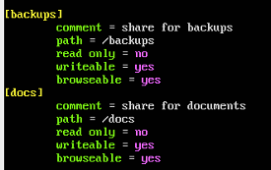

Mkdir /docs

Mkdir /backups

Sudo chown alex:alex /backups

Sudo chown alex:alex /docs

Accessing shares from xp machine



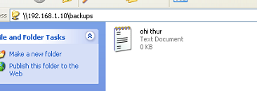

PART 4

Sudo apt-get install apache

Sudo cp /var/www/index.html /var/www/index.html_assign2

